Bridgewater Fall Fest Shirts
Order Form

Front
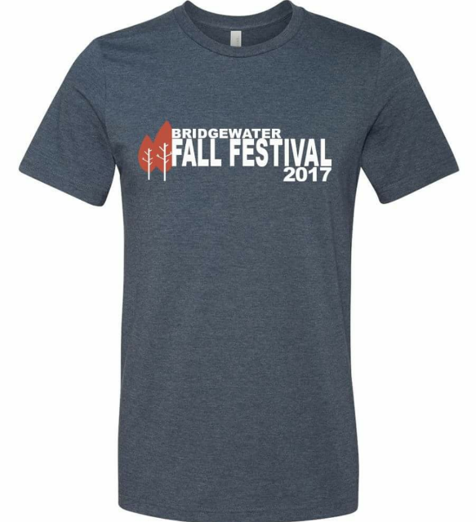
Back of shirt will list
the event sponsors

All Shirts $12

August 23rd deadline

Please make checks payble: Bridgewater Activities Club
Forms can be dropped off at Farmers State Bank

Name: Total Due: $___________
Address:
Phone: Paid:

Write Quantity in Box
Small | Medium | Large | XL | XXL | XXXL

Thank you!!!

